**Prepare a document and with the following screenshot**

Report view

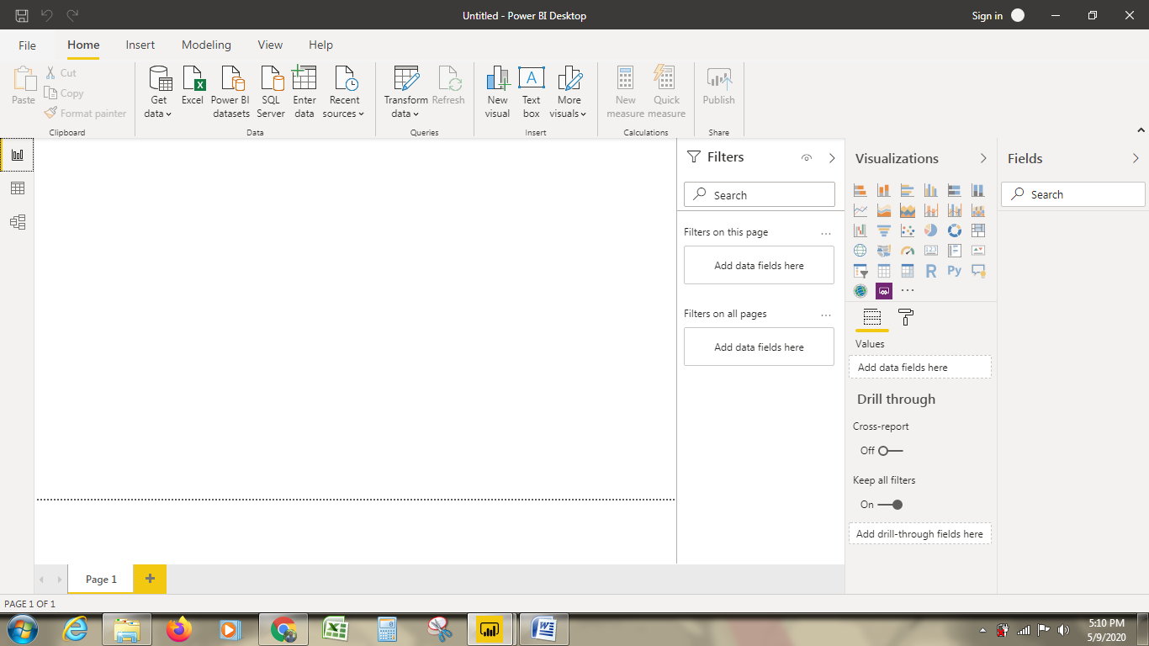

Data view



Model view

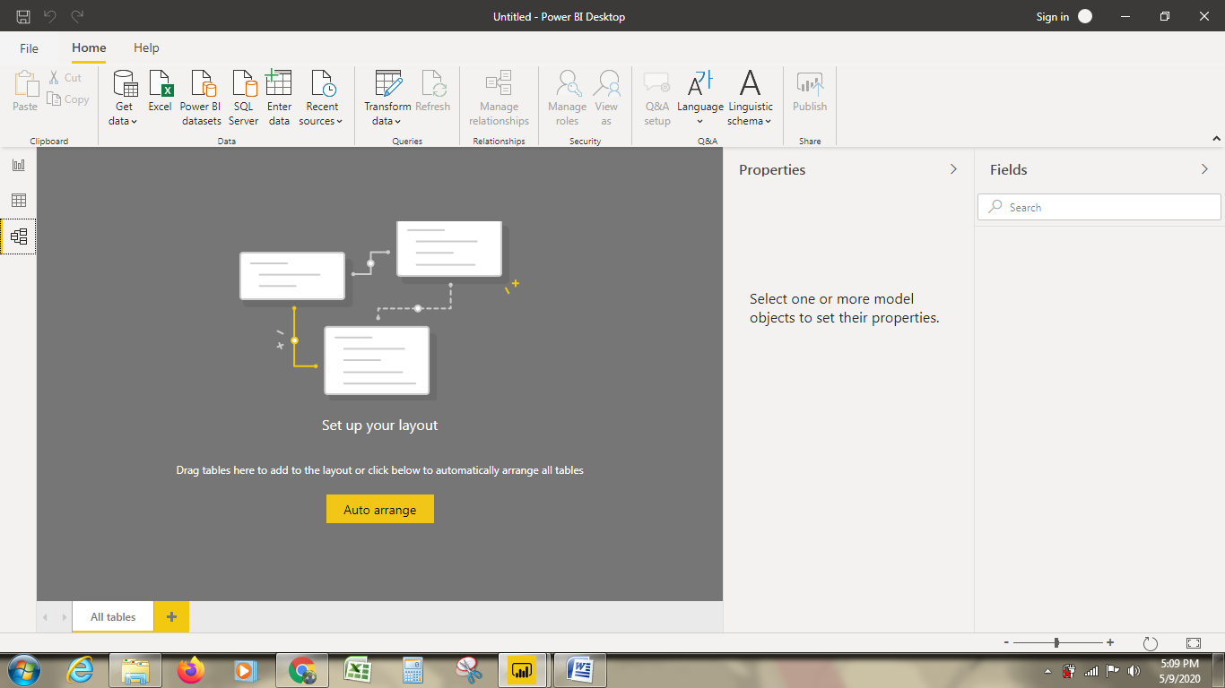

Power Query Editor

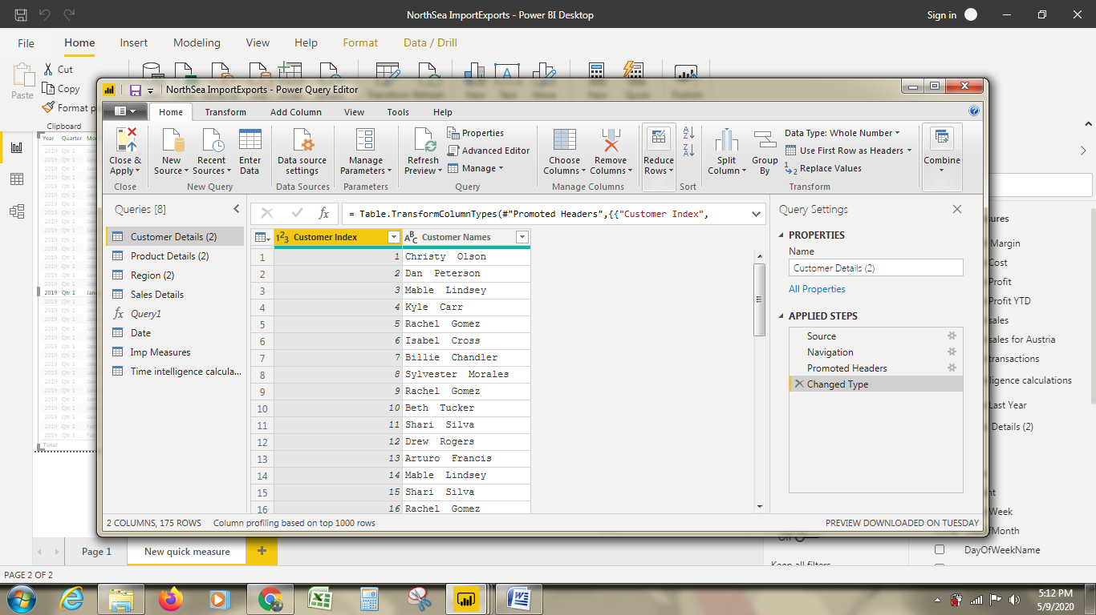

Advance Editor

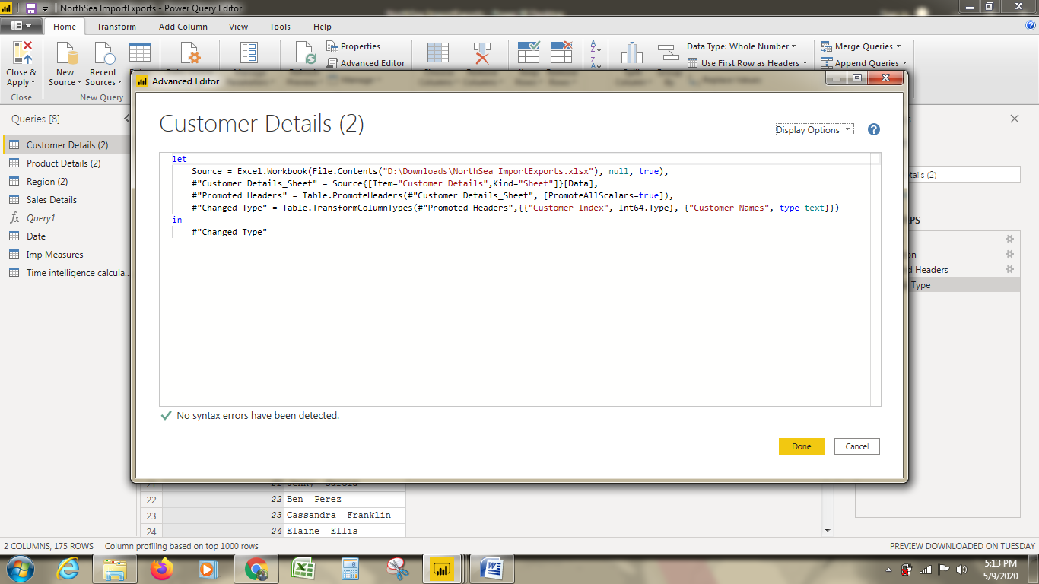

**Prepare a document with details of the following along with their price**

Power BI Desktop: Free

Power BI Pro: $9.99/user/month

Power BI Premium: $4,995. Monthly price per dedicated cloud compute and storage resource with annual subscription.